**Enterprise Resource Planning**

*Of*

**ZAB**

**Training User Manual**

**(SV–12.3.0 | MV–1.0.0)**

**For**

**ASIATIC GROUP**

**Production (Planning & Recipe Setting)**

**Index**

|  |  |  |
| --- | --- | --- |
| **Option No.** | **About** | **Page No.** |
|  | Planning Approval | **03** |
|  | Production Planning | **04** |
|  | Recipe Setting | **06 - 10** |

**Production Part**

For **Recipe Setting** of Production,

As per **Export LC Manual**,

Go to Option **PLANNING APPROVAL**

# Planning Approval

|  |  |
| --- | --- |
| **Step 1** | Main Menu (Home Icon) **> Production >**  **Planning Approval** |
| **Step 2** | Pick an Order Number from the side list & then click **Show** |
| **Step 3** | Click **Approve (**To Approve later click **Hold)** |
| **Result** | The Order will be approved |

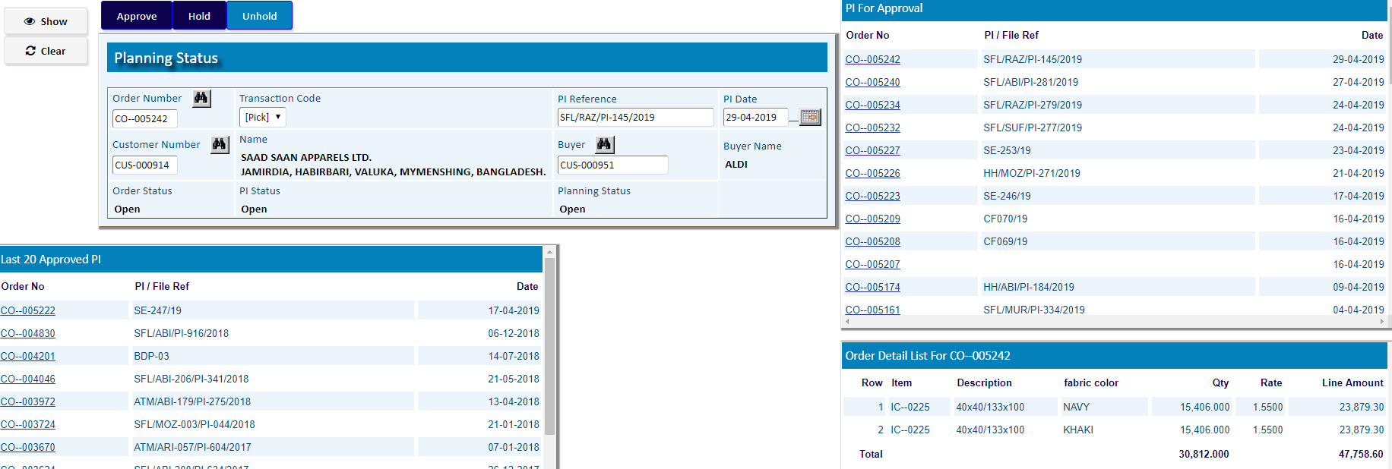

# Production Planning

* Production Planning Header

|  |  |
| --- | --- |
| **Step 1** | Main Menu (Home Icon) **> Production >**  Production Planning |
| **Step 2** | Write Customer Order No., Qty Yard/Meter etc. |
| **Step 3** | Add fabric Construction, Grey Fabric Store, Recipe Store |
| **Step 3** | Assign the Starting Process & Click **Add** |
| **Step 4** | to Add Products Click **Detail** |

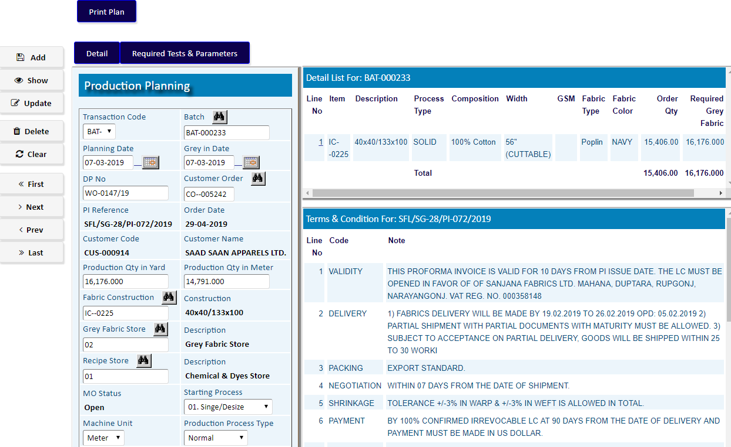To add Required Test & Parameters click on button **Required Test & Parameters**

After finishing **Add** of Required Test & Parameters, click **Complete**

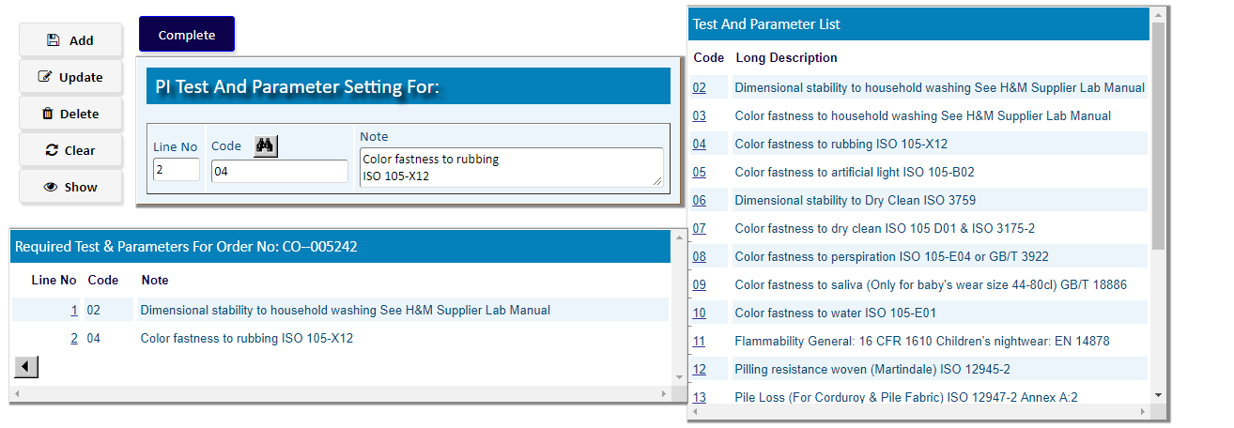

To Add Products Click **Detail**

* Production Planning Detail

1. Pick a product from the side list of PI Detail
2. Write Selling Unit, Fabric Color.
3. Fill the other Info
4. Click **Add**

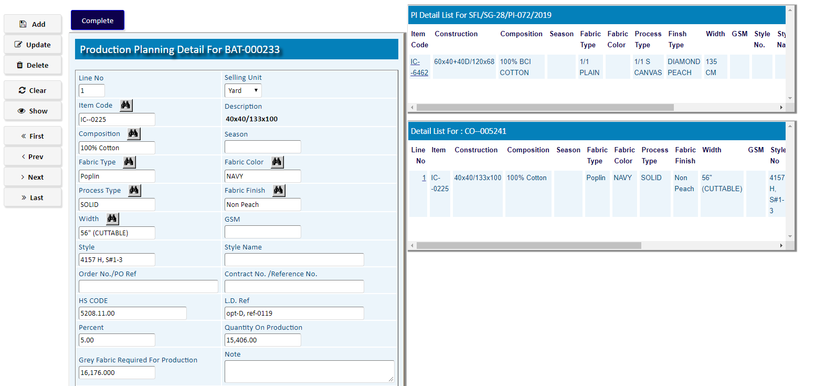

After adding the products, Click **Complete**

# Recipe Setting

|  |  |
| --- | --- |
| **Step 1** | Main Menu (Home Icon) **> Production >**  Recipe Setting |
| **Step 2** | Choose a batch number & click **Show** |
| **Step 3** | Click on **Recipe Setting** to add required fabric & chemical (recipe) for production. |

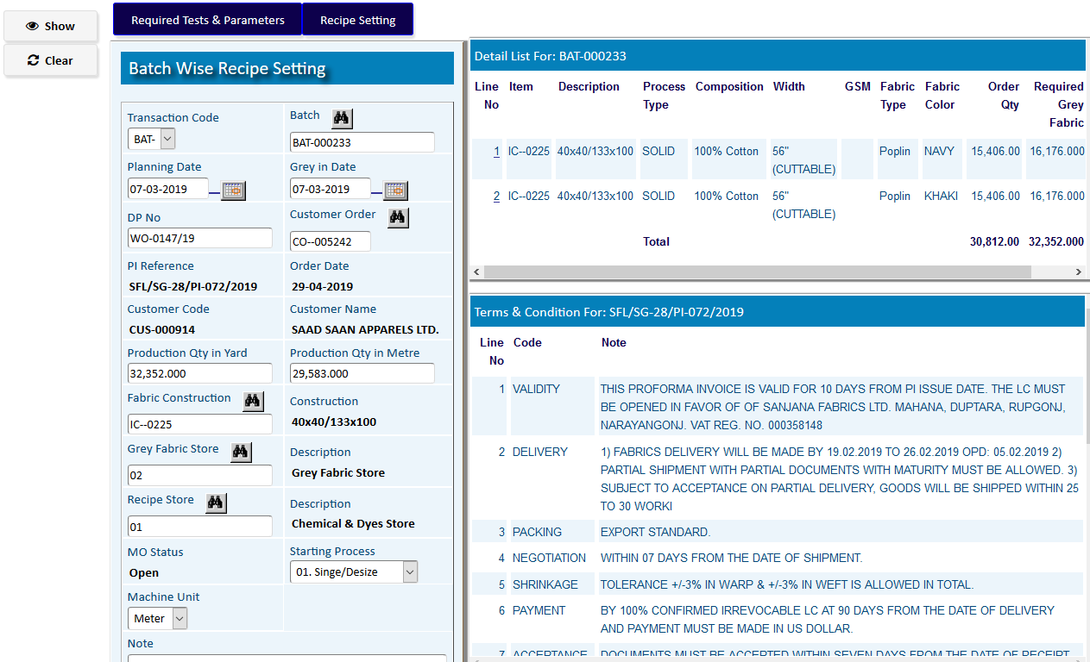

Click on **Recipe Setting** to add required fabric & chemical (recipe) for production.

1. Select Process Name (at first, First Process of Production) & Fabric Color.
2. Click **Add**
3. Repeat a & b to add more process & fabric
4. click on **Recipe Setting** buttonto add materials for eachprocess & fabric

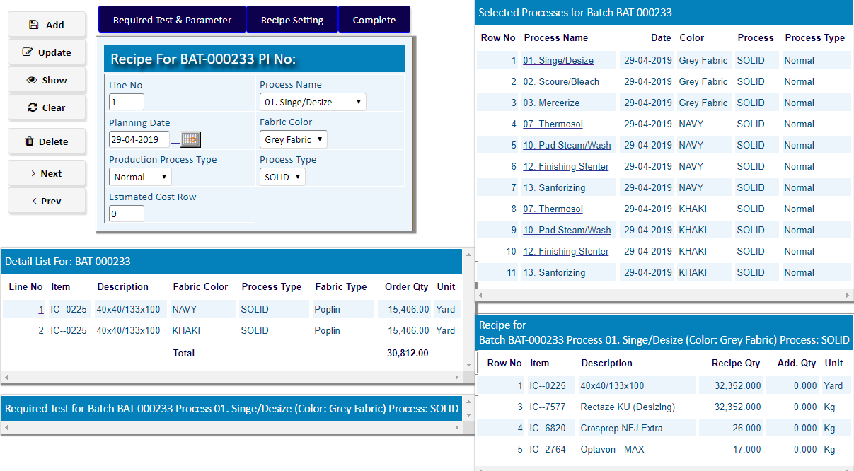

**Recipe Setting** For: Process: >>

1. Select Item Code & Recipe Qty
2. Click **Add**
3. Repeat a & b to add more materials
4. to go back, click on **Complete** buttonafteradd materials

**Recipe setting** For: Process: 01. Singe/Desize

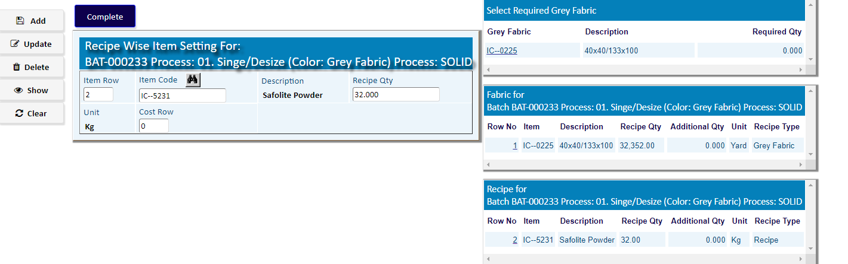

**Recipe setting** For: Process: 02. Scoure/Bleach

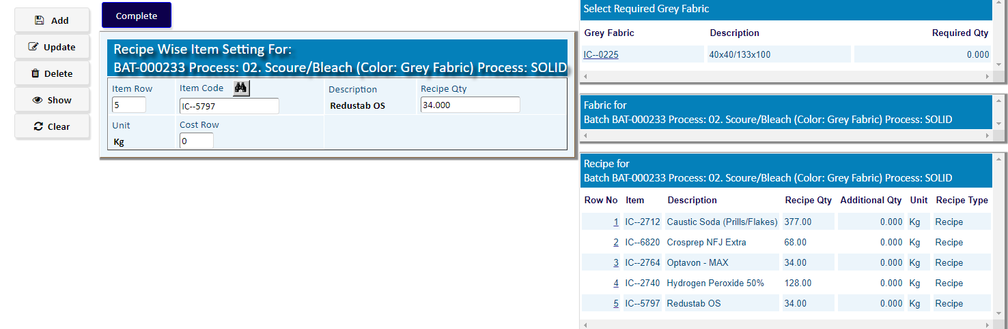

At last, click on **Complete** buttonafter **Add** materials for all processes



Click on **Print Recipe** button to show all Recipe Materials of **Production**

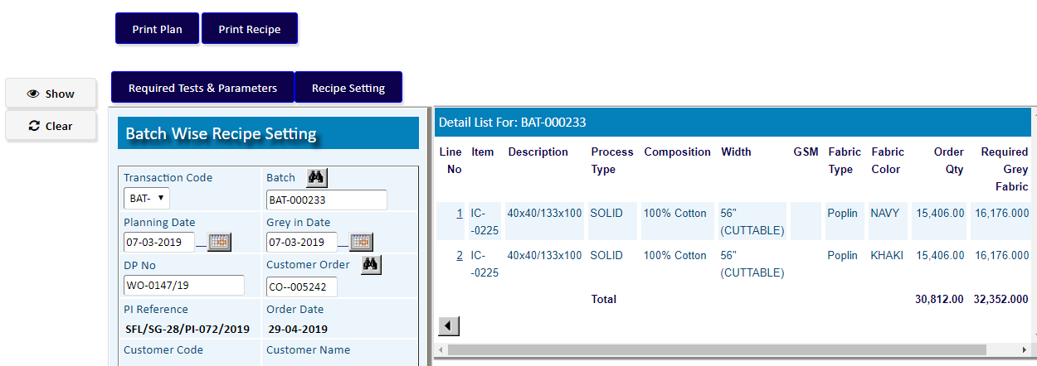

After ending **Recipe Setting** of Production,

As per **Store Requisition Manual**,

Go to Option **Store Requisition (Batch)**